Progressive Lesson Overview
Grade: Kindergarten
Goal:
The goal of this lesson was to help my students struggling in math grasp the meaning of the numbers one through ten.
Learning Objective:
Students will be able to put the numbers in order from one to ten.
Students will be able to use one to one correspondence to count the frogs.

Kindergarten Common Core State Standard 4:
Move students to understand the relationship between numbers and quantities; connect counting to cardinality.
a) When counting objects, say the number names in the standard order, pairing each object with one and only one number name and each number name with one and only one object.
b) Understand that the last number name said tells the number of objects counted. The number of objects is the same regardless of their arrangement or the order in which they
were counted.
c) Understand that each successive number name refers to a quantity that is one larger.

Materials:
- Ziplock Baggies
- Frog Erasers
- Sharpie
- Frog Ten Frame
- Purple Foam Numbers
- Playdough
- Playdough Number Laminations
Group:
The group doing this activity was a group of our lowest students in math. Some of the students are just not developmentally ready for the concepts we are supposed to be teaching them, so we put them in a focus group. This group gets to spend some of math time in a small group setting with either the lead teacher or me. Our goals is for every student in this group to develop number recognition (1-10), one to one correspondence, counting 1-10, and number order.
AM Group: Student One, Student Two
PM Group: Student Three, Student Four, Student Five, Student Six, Student Seven, Student Eight
Day 1
Steps:
- Create frog baggies. Write a number on the front of the bag in sharpie, and then put that many frog erasers in the bag. Do numbers 1-10.
- Either allow students to organize frog baggies separately or alone.
Social Goals:
Working together, taking turns, and teaching each other.
Results:
Too Easy: Student Five, Student Six, Student Two
Just Right: Student Four, Student Seven, Student Eight
Challenging: Student One, Student Three
For some of the higher students in the group (Student Five, Student Six, and Student Two) it was very easy to put the baggies in the right order without counting the frogs. Student Four, Student Seven, and Student Eight struggled a little more, but they were able to organize them after counting the frogs in the bag. Student Three and Student One needed to be walked through the process of counting the frogs because of their lack of one to one correspondence.
Reflection:
Tomorrow I will jump some student ahead to the next activity, and let them leave early so I can have a more focused approach to the other students who need a little more help. I will have Student Four, Student Seven, Student Eight, Student One, and Student Three all do the frog baggies again tomorrow but Student Five, Student Six and Student Two are going to start on the next activity. Once Student Four, Student Seven, Student Eight, Student One, and Student Two are done with the frog baggies I will move them up into the next activity.
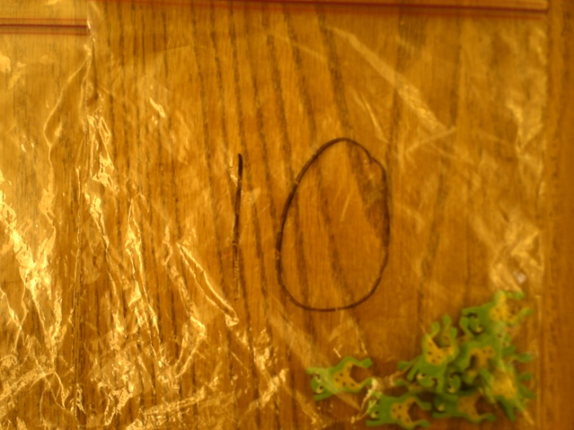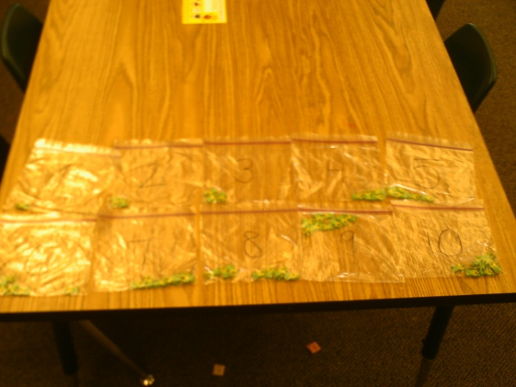
A close up of a frog baggie. All ten frog baggies.
Day 2
Steps:
- Have Student Six, Student Two, and Student Five work with the ten frames. Pair Student Five and Student Six up.
- Have Student Three and Student Eight work together on the frog baggies and then the ten frame.
- Have Student Four and Student Seven work together on the frog baggies and then the ten frame.
Social Goals:
Working together, taking turns, and teaching each other.
Results:
Too Easy: Student Six, Student Two
Just Right: Student Five, Student Four, Student Eight
Challenging: Student Three, Student One, Student Seven
Student Six and Student Two had to count the ten frames maybe once or twice, but they did not ask for any extra help and were more than willing to just tell their partner what to do next instead of waiting (maybe introduce board games later to help them learn to take turns). Student Five, Student Four, and Student Eight did great when working with a partner, especially if their partner understood less than they did. They really blossomed when given the opportunity to teach others. Student Three, and Student Seven almost completely relied on their partner to help them finish once they passed five. Student One did not have a partner, but she needed my help to count the frogs (one to one correspondence).
Reflection:
Student Six and Student Two can jump right up to the foam numbers tomorrow. Student Five, Student Four, and Student Eight will do the ten frames on their own, and Student Three, Student One, and Student Seven will work on the frog baggies by themselves and then move up.
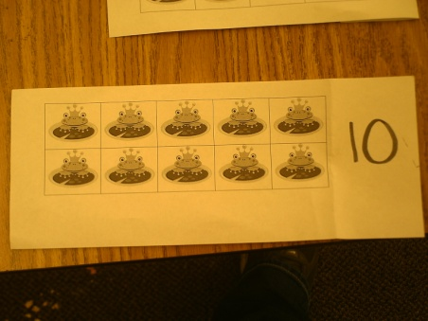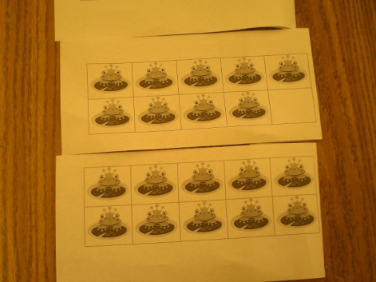
Frog Ten Frame open. Frog Ten Frame closed.
Day 3
Steps:
- Student Two and Student Six jump right into foam numbers.
- Student Eight, Student Four, and Student Five start off with the ten frames, move up into the foam numbers.
- Student Seven, Student One, and Student Three do the frog baggies first, then ten frames, then foam numbers.
*Students are working independently.
Results:
Too Easy: Student Two, Student Six, Student Five
Just Right: Student Eight
Too Challenging: Student Three, Student One, Student Four, Student Seven
Reflection:
Student Six and Student Two are ready to be moved out of this group, and have more math centers time. Student Five is doing well, and is almost ready, so we will do a few more days of observation to see what happens. Student Eight is almost ready with her number recognition and ordering, but she could use a little more work as well. Student Three, Student One, Student Four and Student Seven need to stay in the group for a quite a bit longer. Student Seven needs to work on number recognition and number ordering, but he is getting very close to know them all. He has 1-6 completely down, but gets confused 7-10.
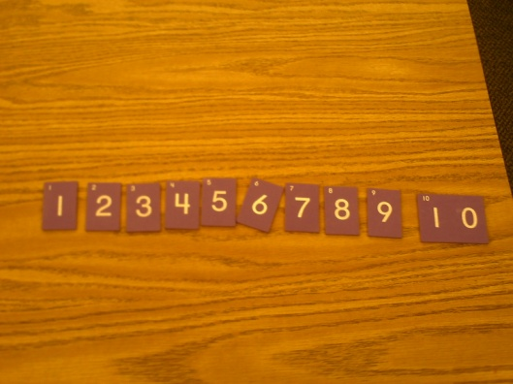
Student One, Student Four, and Student Three were doing great until they got the foam numbers. Of the three Student Four is the best at number recognition and putting the numbers in the order, but like Student Seven he guesses 7-10. And if a number is pulled out at random Student Four has a 50/50 of knowing what the number is by sight alone. Student Three and Student One can get 1-3 everyday, but struggle with different numbers every day. Sometimes they can make it up to 8, other days I cannot get them up to 2. They need a lot more sensory work (which Student Four would very much benefit from as well).
Foam Numbers.
Day 4
Steps:
- Student Three, Student Four, and Student One put the frog baggies into order.
- Teacher asks each child individually, “What number is this?” with all of the foam numbers. Organize them into piles of what the child knows and does not.
- Give the students a playdough sheet (lamented sheet with a ten frame of aliens, a number with arrows, and an empty ten frame) and playdough. Have them work on the numbers that they could not directly tell you the answer too.
Results:
The students really took a liking to this activity. There was some frustration when they were trying to create the number, but once the arrows were explained to them it made a lot more sense. They were only able to get to two numbers (out of the 4-7 numbers they did not know), but this is an activity that can be used repeatedly.
Reflection:
This would be a good activity to have them keep working on until those numbers have been learned; it is also helpful in developing the ten frame concept in the student’s minds. I believe these students need a lot more hands on things (such as playdough) before they are going to fully understand the numbers 1-10. So I should bring in more sensory activities so we can change it up.

