Space Invaders

Standard:
K.CC.5; Count Objects to answer how many there are.

Objective:
Students will count spots and record the number.

Steps:
- Introduce the game on Monday. Set it up as one of the math centers.
  - Show an example (work through 2-3 aliens).
- Allow students to work independently all week.
- Regularly check students work and see if they understand the concept.

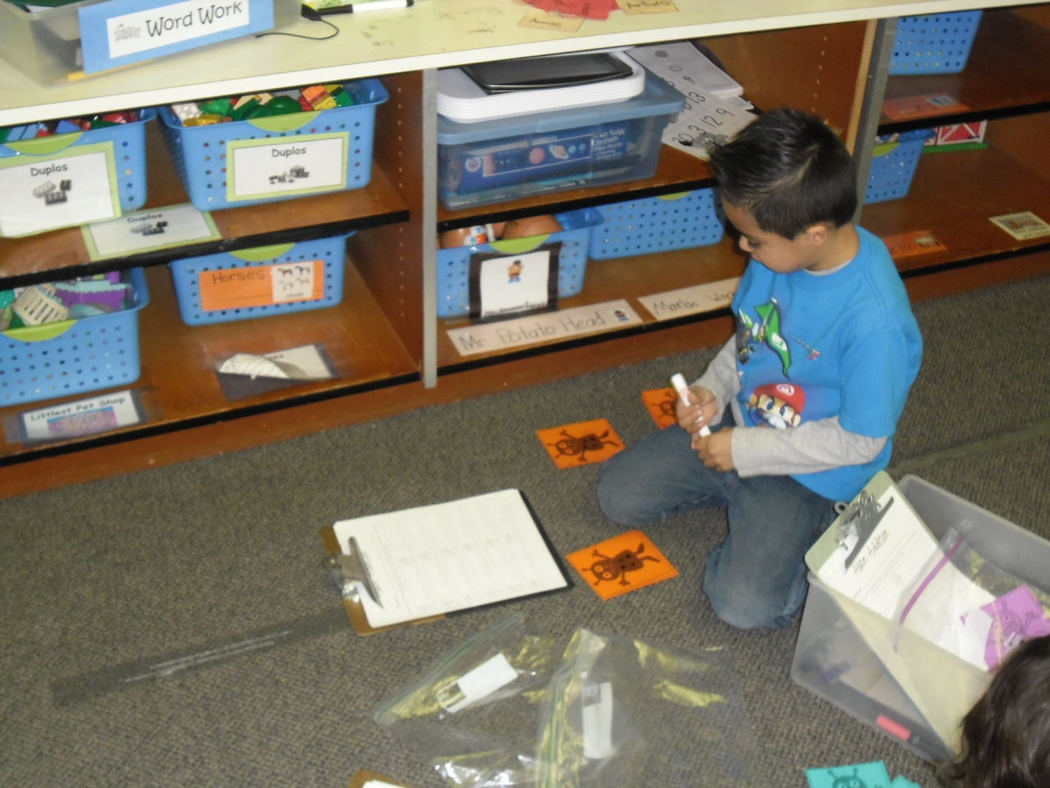

Alien Addition

Standard:
K.OA.5; Fluently add/subtract within five.

Objective:
Students will be able to add two numbers together and write down the equation.

Steps:
- Introduce the game on Monday. Set it up as one of the math centers.
  - Show an example (Work through 2-3 equations).
- Allow students to work independently all week.
- Regularly check students work and see if they understand the concept.

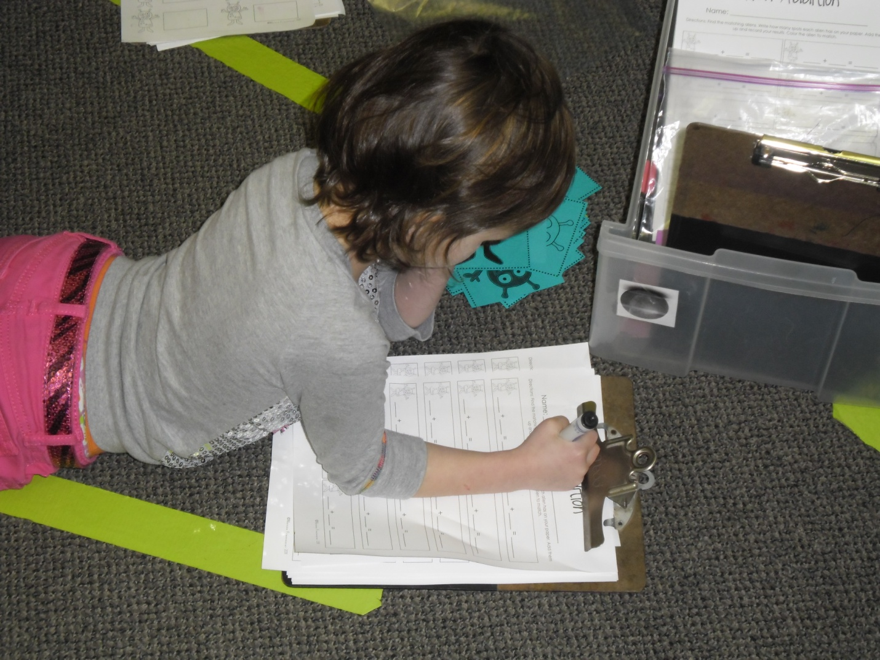

Galaxy Graphing

Standard:
K.MD.2; Compare two objects when measuring (more than, less than)

Objectives:
Students will be able to complete a graph.
Students will be able to understand which was rolled the most while playing.

Steps:
- Introduce the game on Monday. Set it up as one of the math centers.
  - Show an example (roll the dice 2-3 times).
- Allow students to work independently all week.
- Regularly check students work and see if they understand the concept.

Stargazing

Standard:
K.CC.PWR.3: Know and apply grade-level phonics and word analysis skills in decoding words.
Specifically: c. Read Common high-frequency words by sight.

Objectives:
Student will sound out high frequency words.
Student will practice writing high-frequency words.

Steps:
- Introduce the new Word Work on Monday. Set it up as one of the math centers.
  - Show them how to use the telescope. (Talk about a real telescope).
- Allow students to work independently when they use this as their Daily Five Word Work choice.
- Make sure every student has an opportunity to do this word work.

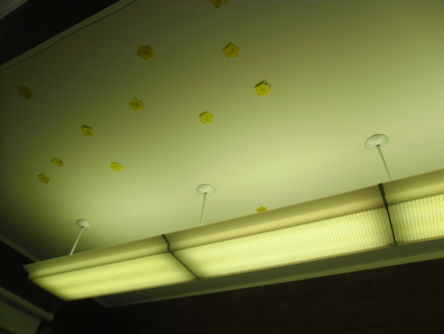
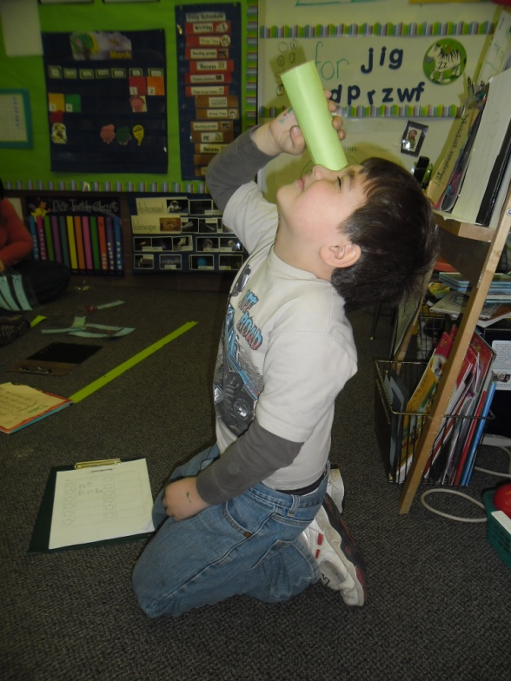

My List

Standard:
K.CC.W.2; Use a combination of drawing, dictating, and writing to compose informative/explanatory texts in which they name what they are writing about and supply some information about the topic.

Objectives:
Students will create a list that is all about a big topic.
Students will practice their fine motor skills.

Steps:
- Break students into small groups.
- Work with the students on writing; show them where the references are.
- Make sure they are staying in the same topic.
- Celebrate a well done finished list.

